Section 1: Case Summary

Scenario Title: | STEMI on the Ward
Keywords: | Cardiology, STEMI
Brief Description of Case: | This case involves the identification and initial management of the STEMI patient. He will require supportive care, antiplatelet/anticoagulation, and cardiology consultation. The patient will continue to complain of chest “discomfort/pressure” throughout the case.

Goals and Objectives
Educational Goal: | To practice the identification and initial management of the STEMI patient
Objectives:  (Medical and CRM) | 1. Perform a focused history and physical exam for the patient with chest pain  2. Provide an interpretation of the clinical situation to the supervising physician  3. Prioritize investigations and initial management plan  4. Develop a differential diagnosis for acute onset of chest pain  5. Consider relative contraindications to nitroglycerin
EPAs Assessed: | N/A

Learners, Setting and Personnel
Target Learners: | ☒ Junior Learners |  | ☐ Senior Learners |  |  | ☐ Staff
 | ☒ Physicians | ☐ Nurses |  | ☐ RTs | ☐ Inter-professional
 | ☐ Other Learners:
Location: | ☒ Sim Lab |  | ☐ In Situ |  |  | ☐ Other:
Recommended Number of Facilitators: | Instructors: 1
 | Sim Actors: 1
 | Sim Techs: 1

Scenario Development
Date of Development: | 2015
Scenario Developer(s): | Dr. Tim Chaplin
Affiliations/Institutions(s): | Queen’s University
Contact E-mail: | chaplintim2@gmail.com
Last Revision Date: | Jan 2020
Revised By: | Dr. Chris Heyd
Version Number: | 1

Section 2A: Initial Patient Information

- Patient Chart
Patient Name: Melvin White |  |  |  | Age: 64 | Gender: M | Weight: 80kg
Presenting complaint: Chest pain
Temp: 36.5 ºC | HR: 95 | BP: 130/80 |  | RR:18 | O₂Sat: 92% | FiO₂: 2L NP
Cap glucose: 8.9 |  |  |  | GCS: 15
Triage note:
It’s 5:00 am and you’ve been called to see a patient complaining of “chest discomfort”. This is a 64M who is admitted to the floor with pneumonia and was transitioned to oral antibiotics yesterday. The chest discomfort started at 4:40 and didn’t respond to the patient’s regular antacid medication.

Allergies: None
Past Medical History:  COPD  Type 2 DM  Hypertension  GERD |  |  | Current Medications:  Flovent  Ventolin  Metformin  Atenolol  Pantoprazole

Section 2B: Extra Patient Information

A. Further History
Include any relevant history not included in triage note above. What information will only be given to learners if they ask? Who will provide this information (mannequin’s voice, sim actors, SP, etc.)?

RN to provide when asked: Mr. White is recovering from a COPD exacerbation and pneumonia. He called you about 30mins ago for chest “discomfort”. You’ve tried his regular Tums with no improvement in his pain. He looks unwell to you.
B. Physical Exam
List any pertinent positive and negative findings
Cardio: Nil | Neuro: Nil
Resp: Right posterior crackles | Head & Neck: Nil
Abdo: Nil | MSK/skin: Diaphoretic and pale
Other: Uncomfortable

Section 3: Technical Requirements/Room Vision

A. Patient
☒ Mannequin Adult
☐ Standardized Patient
☐ Task Trainer
☐ Hybrid
B. Special Equipment Required
EKG Machine
Oxygen supplies

C. Required Medications
IV fluids
ASA, IV heparin

D. Moulage
Hospital gown
IV in place

E. Monitors at Case Onset
☐ Patient on monitor with vitals displayed
☒ Patient not yet on monitor
F. Patient Reactions and Exam
Include any relevant physical exam findings that require mannequin programming or cues from patient
(e.g. – abnormal breath sounds, moaning when RUQ palpated, etc.) May be helpful to frame in ABCDE format.
A: nil
B: R-sided crackles
C: Uncomfortable with heavy chest pain

Section 4: Sim Actor and Standardized Patients

Sim Actor and Standardized Patient Roles and Scripts
Role | Description of role, expected behavior, and key moments to intervene/prompt learners. Include any script required (including conveying patient information if patient is unable)
Bedside RN | RN NOTES:  - Mr. White is recovering from a COPD exacerbation and pneumonia. He called you about 30mins ago for chest “discomfort”. You’ve tried his regular tums with no improvement in his pain. He looks unwell to you.

Section 5: Scenario Progression

Scenario States, Modifiers and Triggers
Patient State/Vitals | Patient Status | Learner Actions, Modifiers & Triggers to Move to Next State |  | Facilitator Notes
1. Baseline State  Rhythm: Sinus  HR: 95  BP: 130/80  RR: 18  O₂SAT: 92% (2L NP)  T: 36.5ºC  GCS: 15 | Is the patient alert? In distress? Seizing? What symptoms do they currently have? | Expected Learner Actions  Chest pain history/physical  Full set of vital signs including bilateral pulse and BPs  IV crystalloid bolus  Ask for EKG (and old one)  Ask for Chest X-ray  Increase supplemental O₂  Send bloodwork (troponin)  Verbalize appropriate differential diagnosis | Modifiers  Changes to patient condition based on learner action  Nitro given BP → 90/50  Triggers  For progression to next state  All actions complete → 2. EKG Done
2. EKG Done  Rhythm: Sinus  HR: 95  BP: 100/50  RR: 18  O₂SAT: 92% (2L NP) |  | Expected Learner Actions  IV crystalloid bolus  Give ASA  Ask for 15 lead EKG (once interpretation of inferior STEMI)  Consider 2nd antiplatelet  Consider heparin  Call Senior resident/Cardio  Place defib pads | Modifiers  Triggers  All actions complete → 3. Call Cath Lab | Give EKG at beginning of this state
3. Call Cath Lab  Rhythm: Sinus  HR: 95  BP: 110/60  RR: 18  O₂SAT: 92% (2L NP) |  | Expected Learner Actions  Call interventional cardiology  Place 2nd IV  Confirm patient can lie flat  Anticoagulation (if not done) | Modifiers  Triggers  All actions complete → End Case

Appendix A: Laboratory Results (admission bloodwork)

CBC
WBC 14
Hgb 130
Plt 290

Lytes
Na 137
K 3.4
Cl 98
HCO₃ 24
Urea 5.5
Cr 97
Glucose 7.4

VBG
pH 7.36
pCO₂ 54
HCO₃ 24

Appendix B: ECGs, X-rays, Ultrasounds and Pictures

Paste in any auxiliary files required for running the session. Don’t forget to include their source so you can find them later!

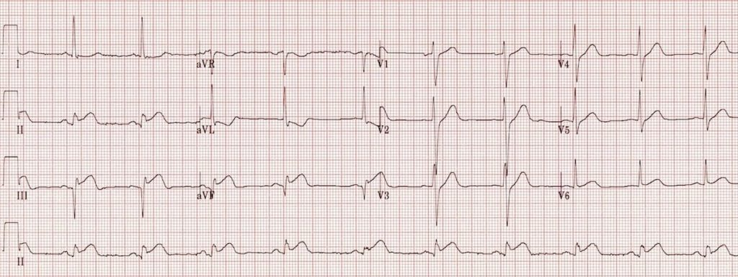
Inferior STEMI (Life in the Fast Lane FOAMeD Blog)
https://litfl.com/wp-content/uploads/2018/08/ECG-Inferior-AMI-STEMI.jpg

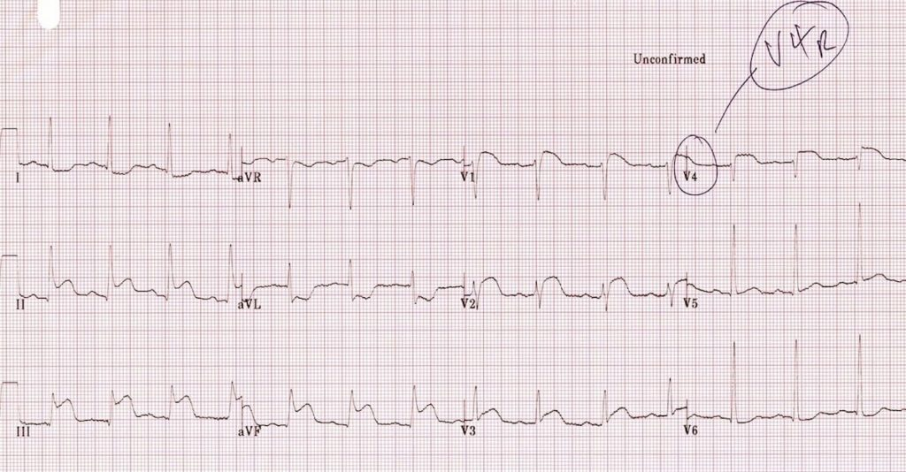
Inferior STEMI with RV involvement on 15-lead EKG (Life in the Fast Lane FOAMeD Blog)
https://litfl.com/wp-content/uploads/2018/08/ECG-Right-ventricular-infarction-1b-V4R.jpg

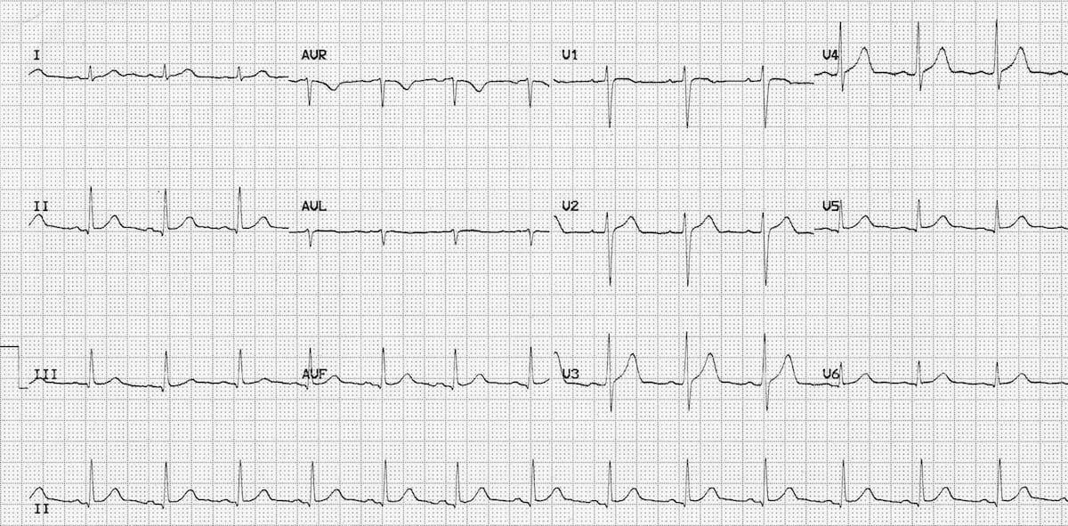
Normal Sinus Rhythm on admission (Life in the Fast Lane FOAMeD Blog)
https://litfl.com/wp-content/uploads/2018/08/normal-sinus-rhythm-2.jpg

Appendix C: Facilitator Cheat Sheet & Debriefing Tips

Include key errors to watch for and common challenges with the case. List issues expected to be part of the debriefing discussion. Supplemental information regarding any relevant pathophysiology, guidelines, or management information that may be reviewed during debriefing should be provided for facilitators to have as a reference.

- Organized approach to the unstable ward patient
- Differential diagnoses for acute onset of chest pain
- Communication and teamwork in a ‘crisis’ scenario.
  - Specifically for this case – discuss the importance of an organized communication strategy when discussing clinical scenarios over the phone.
- General concepts in the initial management of the STEMI patient (consider differential, supportive treatment, antiplatelet, anticoagulation, PCI, lytics)
- Discussion of analgesia in STEMI – role of opioids, nitroglycerin (especially which STEMIs need to be cautious with NTG)

References

1. https://litfl.com/wp-content/uploads/2018/08/ECG-Inferior-AMI-STEMI.jpg
2. https://www.ncbi.nlm.nih.gov/books/NBK470572/
3.

